 | ANGLO-CHINESE JUNIOR COLLEGE  JC2 Preliminary Examination  Higher 2

H2 GEOGRAPHY |  | 9173/01
Paper 1 |  | 26 August 2024
Insert |  | 3 hours

READ THESE INSTRUCTIONS FIRST

This Insert contains all the Resources referred to in the questions.

This document consists of 8 printed pages.

Resource 1 for Question 1

Map of Nike production factories

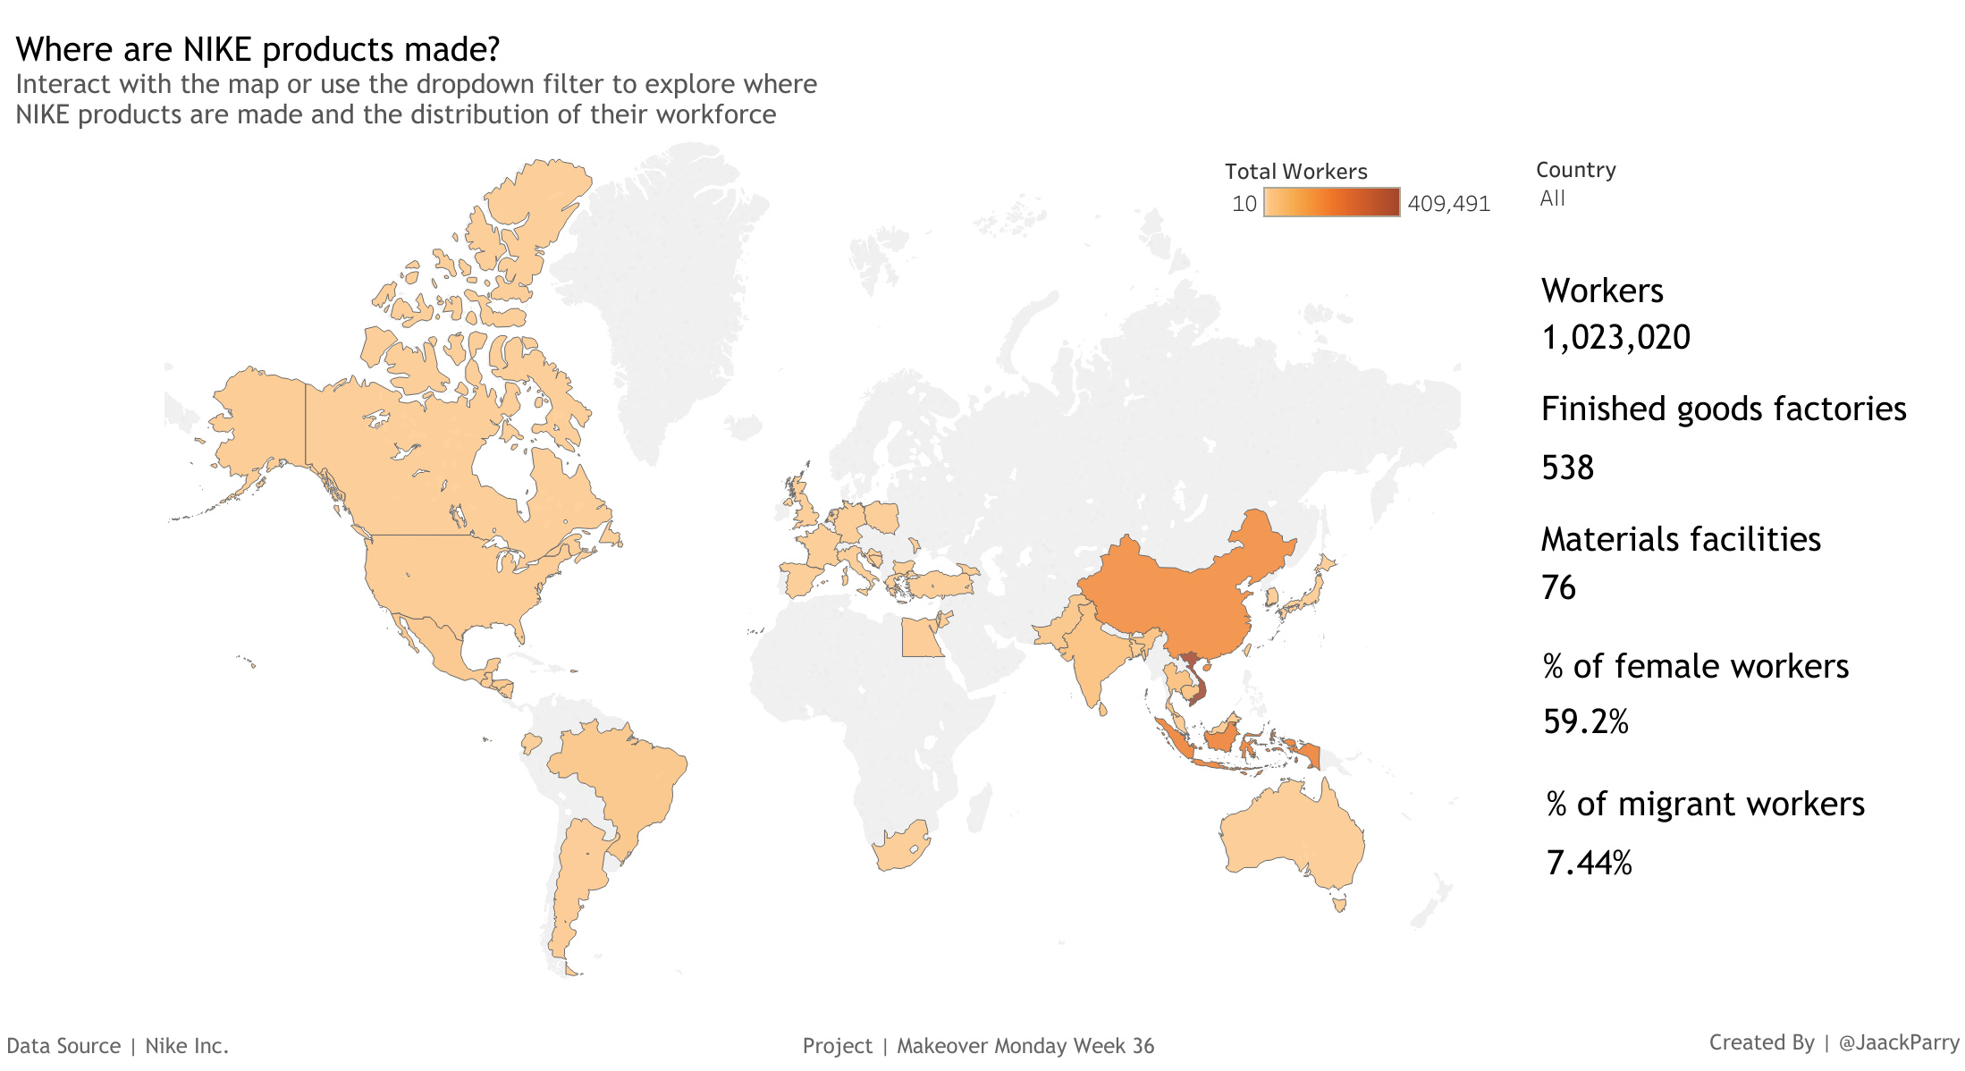

Resource 2 for Question 1

Nike commodity chain

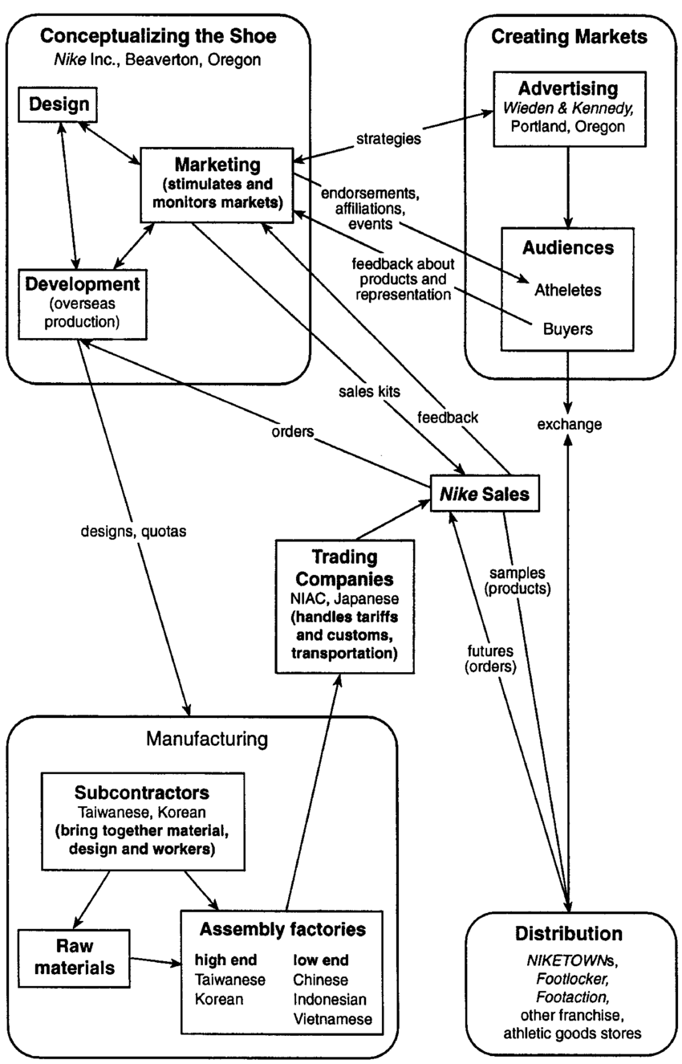
Resource 3 for Question 1

Factors affecting Nike’s global production network

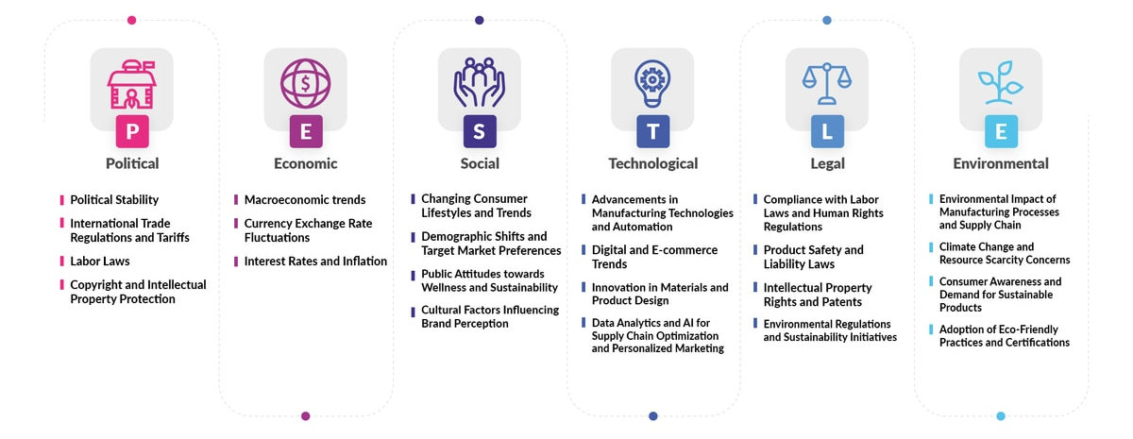

Resource 4 for Question 1

Nike’s sustainability score based on the Sustainable Development Goals (SDGs)

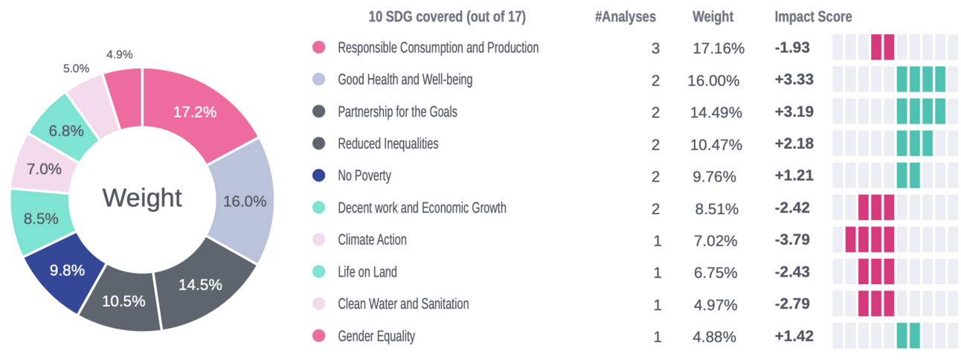

Resource 5 for Question 2

Climate graph of Phang Nga Bay, Thailand
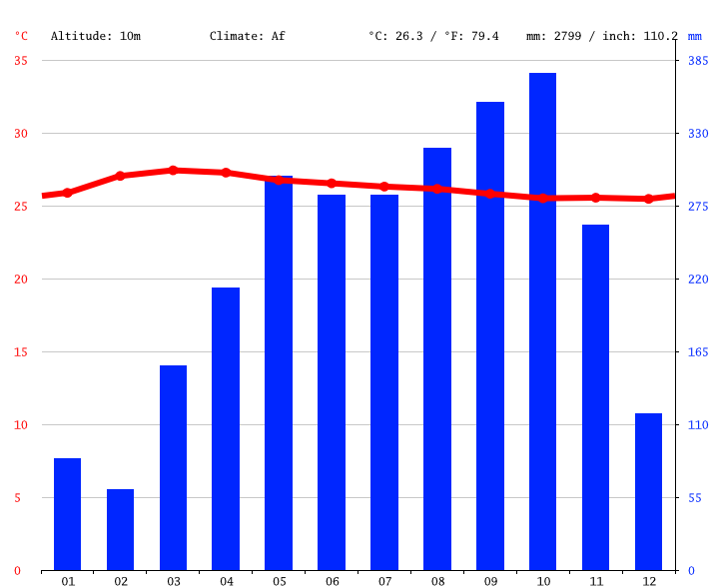
Altitude: 10m Climate type: Am Average temp: 26.3ºC Annual rainfall: 2799 mm

Month

Resource 6A for Question 2

Karst landforms in Phang Nga Bay, Thailand (Tropical Monsoon climate zone)

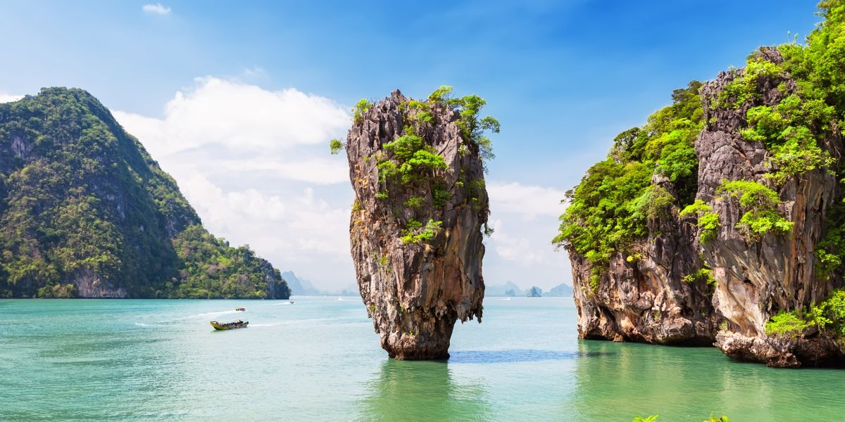

Resource 6B for Question 2

Weathering on rock pedestal in Timna Valley, Israel (Tropical Desert climate zone)
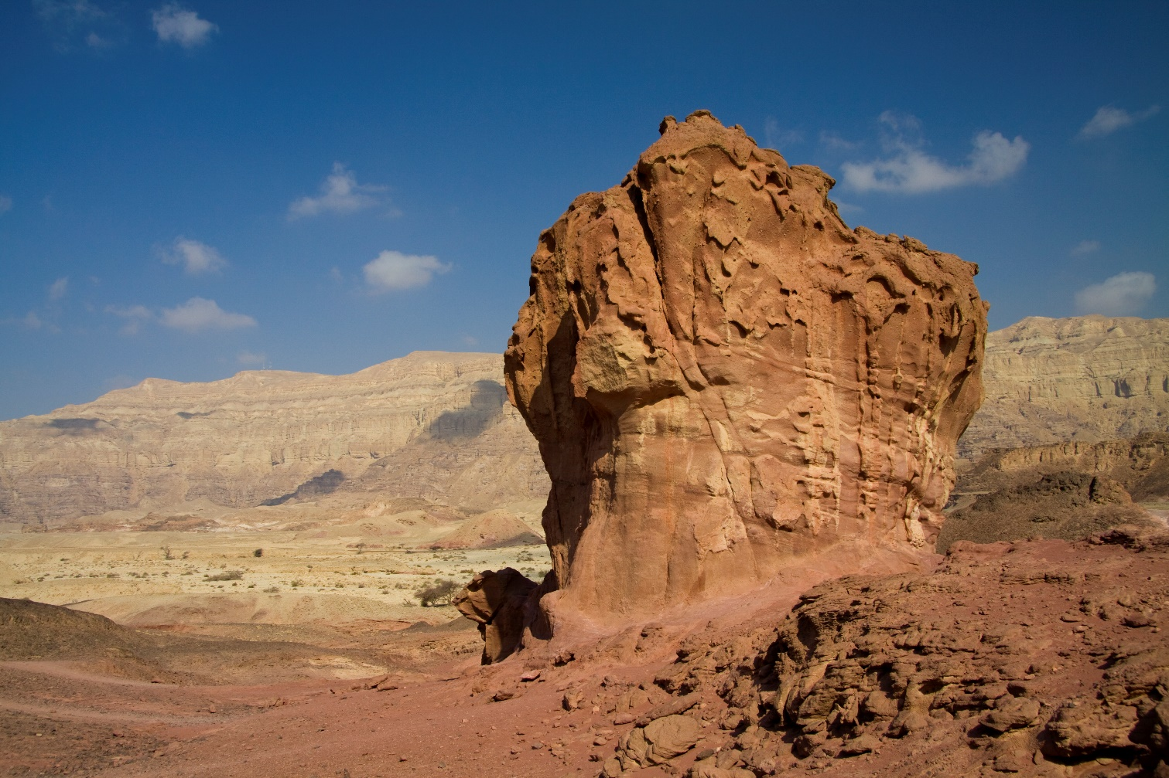

Resource 7 for Question 2

Rockfall at the Halsema Highway near Bontoc, Philippines (July 2022)

